**Batch: A3 Roll No.: 16010121045**

**Experiment No. 04**

|  |
| --- |
| **TITLE:** **Develop and demonstrate JavaScript with POP-UP boxes and functions** |

**AIM:** To demonstrate the functionalities of JavaScript using HTML and CSS

**______________________________________________________________________**

**Expected Outcome of Experiment:** Design static web pages using various HTML tags.

**_______________________________________________________________**

**Books/ Journals/ Websites referred:**

1. .

**_____________________________________________________________________**

Describe and utilize Javascript programming concepts such as variables, arrays, conditionals, and loops.

Write and deploy Javascript code to solve practical web design problems.

**Problem Statement: Description of the application implemented with output**:

**a) Input**: Click on Display Date button using onclick( ) function

**Output:** Display date in the textbox

**b) Input:** A number n obtained using prompt

**Output:** Factorial of n number using alert

**c) Input:** A number n obtained using prompt

**Output:** A multiplication table of numbers from 1 to 10 of n using

d**) Write JavaScript to validate the following fields for the registration page**.

Name (Name should contain alphabets and the length should not be less than 6 characters).

Password (Password should not be less than 6 characters length).

E-mail id (should not contain any invalid and must follow the standard pattern

name@domain.com)

Phone number (Phone number should contain 10 digits only).

**Javascript Basic Concepts Learned With Syntax**

**Variables:**

// declaring a variable

let x;

// initializing a variable

x = 10;

// declaring and initializing a variable

let y = 20;

**Data Types:**

// numbers

let x = 10;

// strings

let y = "Hello";

// booleans

let z = true;

// null

let a = null;

// undefined

let b = undefined;

**Operators:**

// arithmetic operators

let x = 10 + 5; // addition

let y = 10 - 5; // subtraction

let z = 10 * 5; // multiplication

let a = 10 / 5; // division

let b = 10 % 5; // modulus

// comparison operators

let p = 10 < 5; // less than

let q = 10 > 5; // greater than

let r = 10 <= 5; // less than or equal to

let s = 10 >= 5; // greater than or equal to

let t = 10 === 5; // equal to (strict comparison)

let u = 10 !== 5; // not equal to (strict comparison)

// logical operators

let v = true && false; // logical AND

let w = true || false; // logical OR

let x = !true; // logical NOT

**Conditional Statements:**

// if statement

if (condition) {

// code to execute if condition is true

}

// if-else statement

if (condition) {

// code to execute if condition is true

} else {

// code to execute if condition is false

}

// if-else if-else statement

if (condition1) {

// code to execute if condition1 is true

} else if (condition2) {

// code to execute if condition2 is true

} else {

// code to execute if both condition1 and condition2 are false

}

**Loops:**

// for loop

for (let i = 0; i < 10; i++) {

// code to execute in each iteration

}

// while loop

let i = 0;

while (i < 10) {

// code to execute in each iteration

i++;

}

// do-while loop

let i = 0;

do {

// code to execute in each iteration

i++;

} while (i < 10);

**Functions:**

// declaring a function

function add(a, b) {

return a + b;

}

// calling a function

let result = add(10, 5);

// arrow function

let add = (a, b) => {

return a + b;

}

**Description of the application implemented with output**:

a)

<!DOCTYPE *html*>

<html *lang*="en">

<head>

<meta *charset*="UTF-8">

<meta *http-equiv*="X-UA-Compatible" *content*="IE=edge">

<meta *name*="viewport" *content*="width=device-width, initial-scale=1.0">

<title>Exp 3</title>

<link *rel*="stylesheet" *href*="index.css">

</head>

<body>

<input *type*="text" *id*="dateInput">

<button *onclick*="displayDate()">Display Date</button>

</body>

<script>

function displayDate() {

const dateInput = document.getElementById("dateInput");

const today = new Date();

const date = today.getDate();

const month = today.getMonth() + 1;

const year = today.getFullYear();

const formattedDate = `${year}-${month}-${date}`;

dateInput.value = formattedDate;

}

</script>

</html>

b)

const n = parseInt(prompt("Enter a number: "));

let factorial = 1;

*for* (let i = 1; i <= n; i++) {

factorial *= i;

}

alert(`Factorial of ${n} is ${factorial}`);

c)

const n = parseInt(prompt("Enter a number: "));

*for* (let i = 1; i <= 10; i++) {

const result = n * i;

console.log(`${n} x ${i} = ${result}`);

}

d)

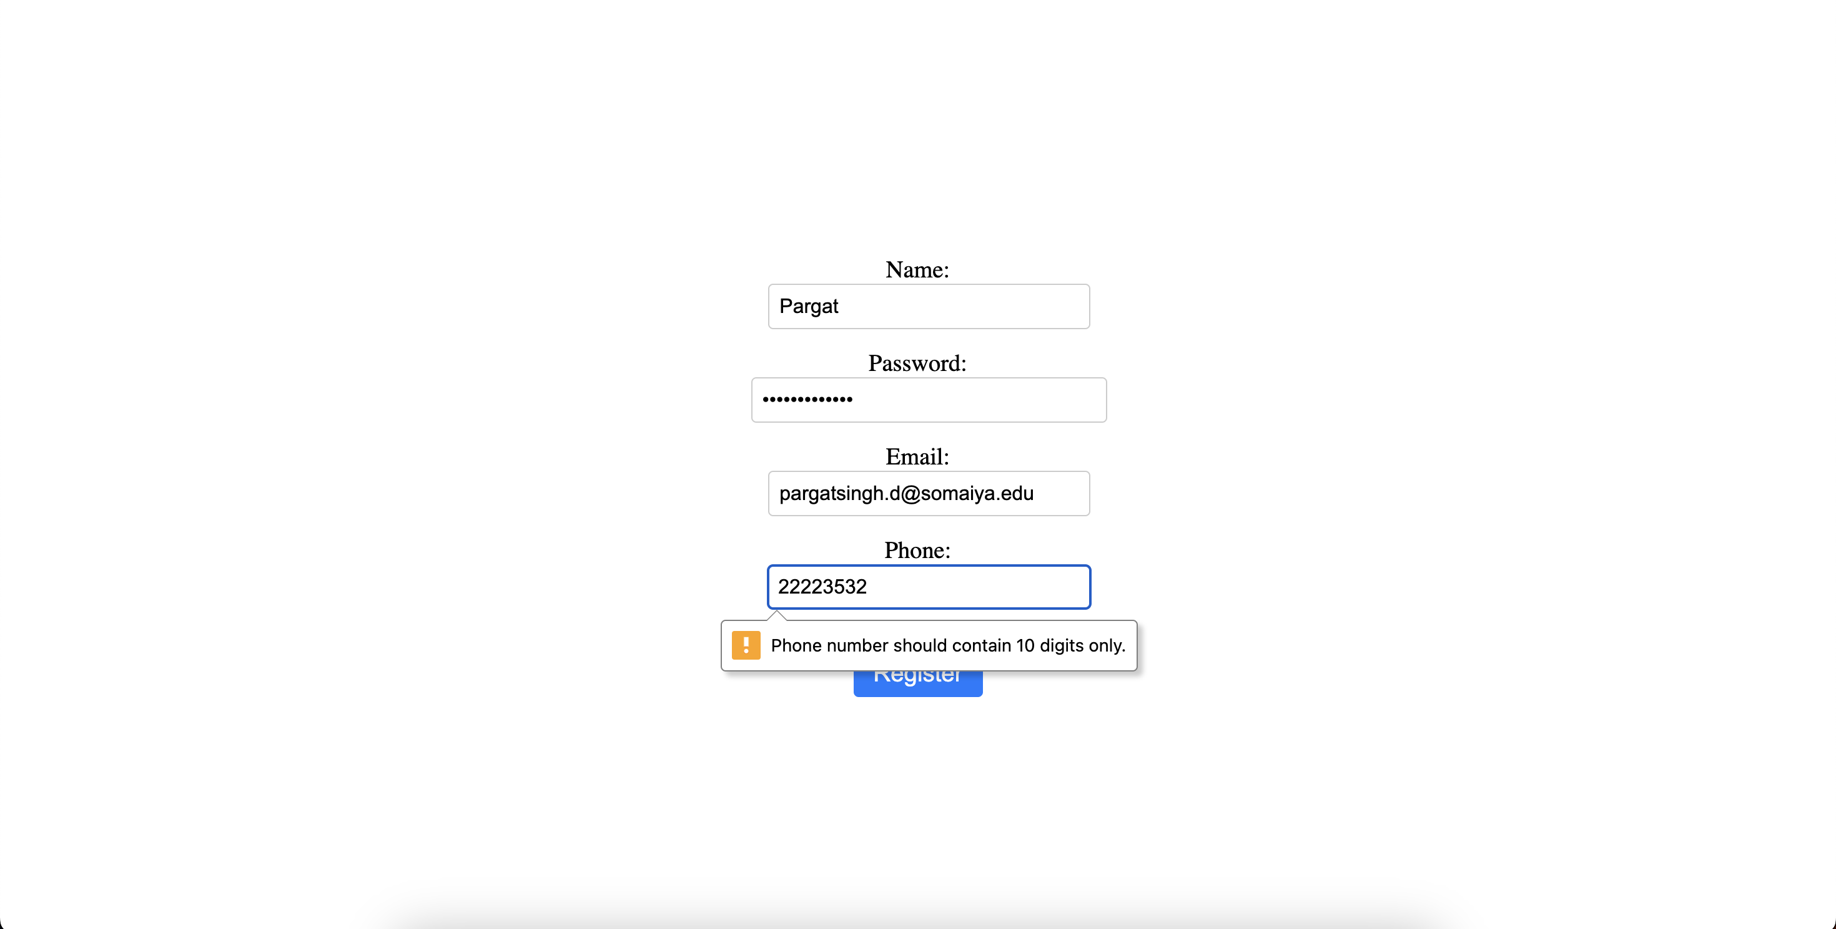

<!DOCTYPE *html*>

<html *lang*="en">

<head>

<style>

section{

height: 100vh;

width: 100%;

display: flex;

align-items: center;

justify-content: center;

text-align: center;

}

*/* Style the form container */*

form {

max-width: 500px;

margin: 0 auto;

display: flex;

flex-direction: column;

justify-content: center;

align-items: center;

}

*/* Style the form labels */*

label {

font-size: 1.2rem;

margin-bottom: 0.5rem;

}

*/* Style the form inputs */*

input {

padding: 0.5rem;

border-radius: 0.25rem;

border: 1px solid #ccc;

font-size: 1rem;

margin-bottom: 1rem;

width: 100%;

}

*/* Style the form button */*

button {

background-color: #007bff;

color: #fff;

padding: 0.5rem 1rem;

border-radius: 0.25rem;

border: none;

font-size: 1.2rem;

cursor: pointer;

margin-top: 1rem;

}

*/* Style the form button on hover */*

button*:hover* {

background-color: #0069d9;

}

</style>

</head>

<body>

<section>

<form>

<div>

<label *for*="nameInput">Name:</label>

<input *type*="text" *id*="nameInput" *required*>

</div>

<div>

<label *for*="passwordInput">Password:</label>

<input *type*="password" *id*="passwordInput" *minlength*="6" *required*>

</div>

<div>

<label *for*="emailInput">Email:</label>

<input *type*="email" *id*="emailInput" *required*>

</div>

<div>

<label *for*="phoneInput">Phone:</label>

<input *type*="tel" *id*="phoneInput" *pattern*="[0-9]{10}" *required*>

</div>

<button *type*="submit">Register</button>

</form>

</section>

</body>

<script>

const nameInput = document.getElementById("nameInput");

const passwordInput = document.getElementById("passwordInput");

const emailInput = document.getElementById("emailInput");

const phoneInput = document.getElementById("phoneInput");

nameInput.addEventListener("input", validateName);

passwordInput.addEventListener("input", validatePassword);

emailInput.addEventListener("input", validateEmail);

phoneInput.addEventListener("input", validatePhone);

function validateName() {

const name = nameInput.value.trim();

*if* (/*^*[a-zA-Z]{6,}*$*/.test(name)) {

nameInput.setCustomValidity("");

} *else* {

nameInput.setCustomValidity(

"Name should contain alphabets and the length should not be less than 6 characters.");

}

}

function validatePassword() {

const password = passwordInput.value;

*if* (password.length >= 6) {

passwordInput.setCustomValidity("");

} *else* {

passwordInput.setCustomValidity("Password should not be less than 6 characters length.");

}

}

function validateEmail() {

const email = emailInput.value.trim();

*if* (/*^*[^\s@]+@[^\s@]+\.[^\s@]+*$*/.test(email)) {

emailInput.setCustomValidity("");

} *else* {

emailInput.setCustomValidity("Invalid email format.");

}

}

function validatePhone() {

const phone = phoneInput.value.trim();

*if* (/*^*[0-9]{10}*$*/.test(phone)) {

phoneInput.setCustomValidity("");

} *else* {

phoneInput.setCustomValidity("Phone number should contain 10 digits only.");

}

}

</script>

</html>

**Post Lab Objective with Ans :**

What are the possible ways to create objects in JavaScript?

There are four ways to create an object in JavaScript

* using object literals
* using the function constructor
* using the Object.create method
* using the class keyword

What is the Difference between == and === operators

|  |  |
| --- | --- |
| Double Equals (==) | Triple Equals (===) |
| Double equals named as **Equality Operator**. | Triple equals named as **Identity / Strict equality Operator**. |
| Double equals used as **Type converting** the conversion | Triple equals used as **Strict conversion** without performing any conversion in operands. |
| Double equals has syntax for comparison as (a == b) | Triple equals has syntax for comparison as (a === b) |
| Double equals first convert the operands into the same type and then compare i.e comparison would perform once both the operands are of the same type. This is also known as type coercion comparison. | On the other hand, triple equals do not perform any type of conversion before comparison and return true only if type and value of both operands are exactly the same. |

What is the difference between let and var

The main difference between let and var is that scope of a variable defined with let is limited to the block in which it is declared while variable declared with var has the global scope. So we can say that var is rather a keyword which defines a variable globally regardless of block scope.

The scope of let not only limited to the block in which it is defined but variable with let also do not get added with global window object even if it get declared outside of any block. But we can access variable with var from window object if it is defined globally.

Due to limited scope let variables are usually used when there is limited use of those variables such as in for loops, while loops or inside the scope of if conditions etc while var variable is used when value of variable need to be less change and used to accessed globally.

Also, one difference between var and let is variable with var can be redeclared to some other value while variable could not be redeclared if it is defined with let.