Batch: A3 Roll No.: 16010121045

Experiment No. 03

TITLE: Demonstrate the use of Bootstrap

AIM: To use bootstrap (open source front-end development framework) for the creation of web pages.
______________________________________________________________________
Expected Outcome of Experiment: Re_design of web pages using various HTML, CSS tags with bootstrap.
_______________________________________________________________
Books/ Journals/ Websites referred:

http://getbootstrap.com/getting-started
_____________________________________________________________________

Problem Statement:

- Students have to re-design web-pages developed in Experiment 1 and 2 by using bootstrap.

- Create a webpage using bootstrap with following features,

i) use a container to set the content's margins dealing with the responsive behaviors of layout.
ii) shape the image into a circle
iii) use bootstrap grid system
iv) create basic pagination
v) insert search icon(glyphicon)

<!-- Nav Bar -->
<nav class="navbar navbar-expand-lg navbar-dark">
<div class="container" id="nav-container">
<a class="navbar-brand" href="#" id="nav-title">tindog</a>
<button class="navbar-toggler" type="button" data-bs-toggle="collapse" data-bs-target="#navbarTogglerDemo01"
aria-controls="navbarTogglerDemo01" aria-expanded="false" aria-label="Toggle navigation">
<span class="navbar-toggler-icon"></span>
</button>
<div class="collapse navbar-collapse" id="navbarTogglerDemo01">
<ul class="navbar-nav mb-2 mb-lg-0 ms-auto">
<li class="nav-item">
<a class="nav-link" aria-current="page" href="#footer">Contact</a>
</li>
<li class="nav-item">
<a class="nav-link" href="#pricing">Pricing</a>
</li>
<li class="nav-item">
<a class="nav-link" href="#cta">Download</a>
</li>
</ul>
</div>
</div>
</nav>

<section id="features">
<div class="row">
<div class="feature-box col-lg-4">
<i class="icon fa-solid fa-circle-check fa-4x"></i>
<h3>Easy to use.</h3>
<p>So easy to use, even your dog could do it.</p>
</div>
<div class="feature-box col-lg-4">
<i class="icon fa-solid fa-bullseye fa-4x"></i>
<h3>Elite Clientele</h3>
<p>We have all the dogs, the greatest dogs.</p>
</div>
<div class="feature-box col-lg-4">
<i class="icon fa-solid fa-heart fa-4x"></i>
<h3>Guaranteed to work.</h3>
<p>Find the love of your dog's life or your money back.</p>
</div>
</div>
</section>

Description of the application implemented with output:
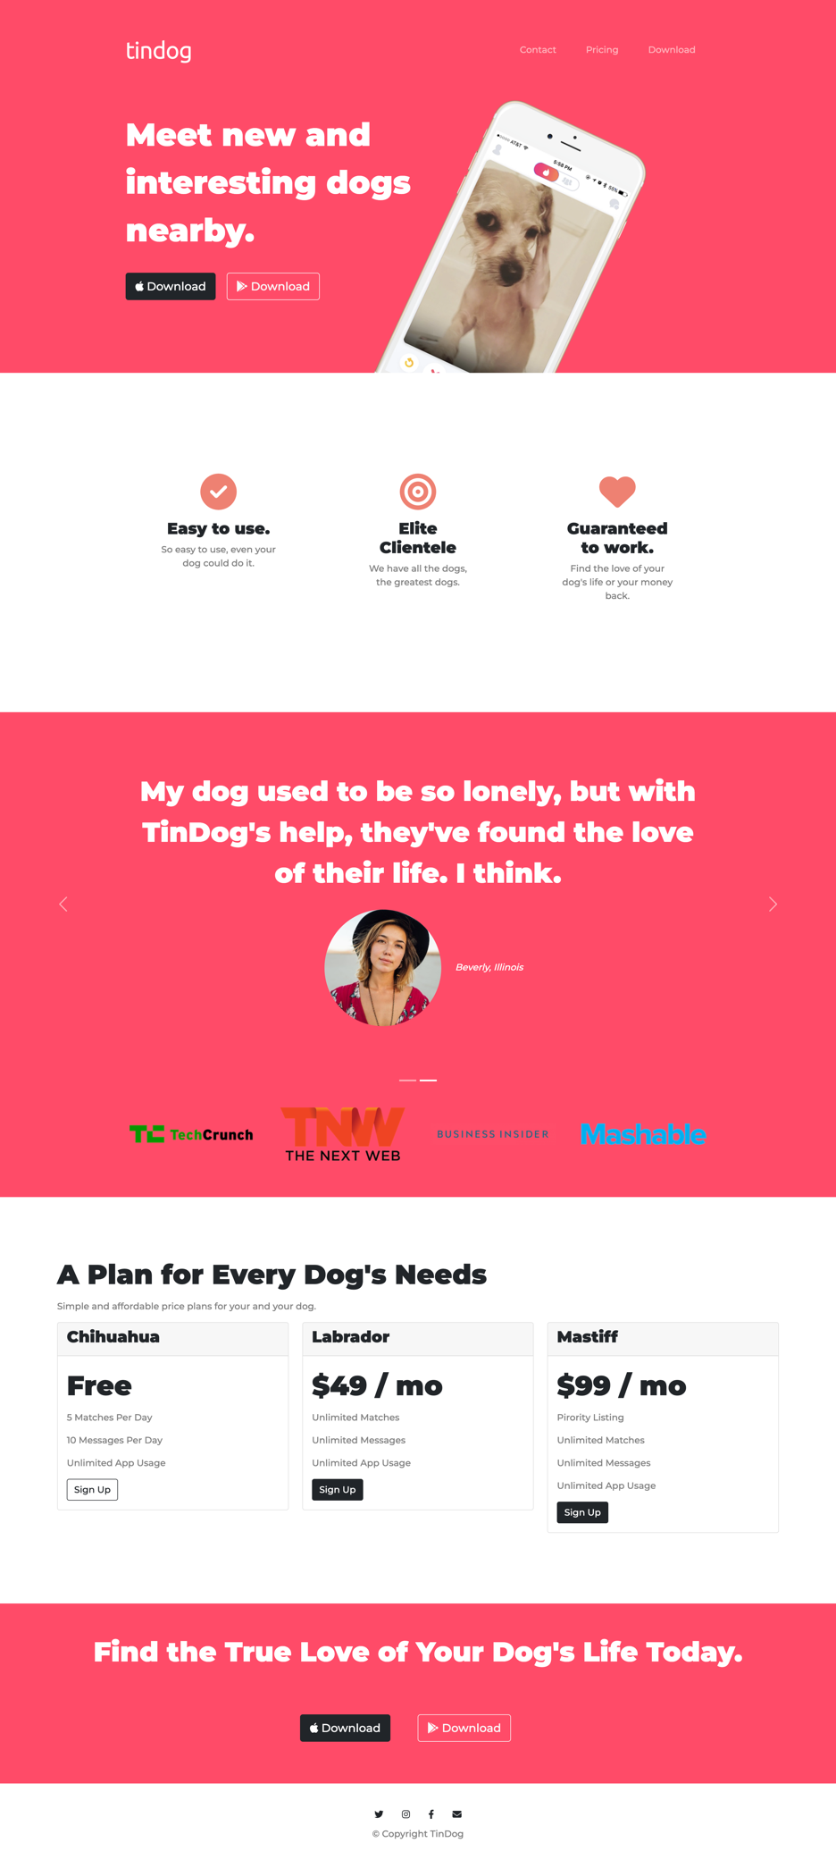
Post Lab Questions:
- What is the use of containers in bootstrap? Explain in detail.

Containers in Bootstrap are used to create a fixed-width container to wrap the content of a webpage. The container is used to center the content and provide a consistent width for the webpage, regardless of the device or screen size used to view it.
In Bootstrap, there are two types of containers - .container and .container-fluid. The .container class creates a fixed-width container with a responsive layout that adjusts based on the screen size. The .container-fluid class creates a full-width container that spans the entire width of the viewport.

Containers in Bootstrap are essential for creating a responsive layout that can adapt to different screen sizes and devices. By using containers, developers can ensure that their content looks good and is easy to read on any device, from desktops to smartphones.

- Name the classes to achieve the different button styles in bootstrap.

Bootstrap provides several classes to achieve different button styles. These classes include:

.btn: This is the basic button class in Bootstrap. It creates a standard button with no special styling.

.btn-primary: This class creates a button with a blue background color, which is the primary color used in Bootstrap.

.btn-secondary: This class creates a button with a gray background color, which is the secondary color used in Bootstrap.

.btn-success: This class creates a button with a green background color, which is often used to indicate success or completion.

.btn-danger: This class creates a button with a red background color, which is often used to indicate danger or a critical action.

.btn-warning: This class creates a button with a yellow background color, which is often used to indicate a warning or caution.

.btn-info: This class creates a button with a light blue background color, which is often used to indicate information or help.

.btn-light: This class creates a button with a light gray background color, which is often used for less important actions or secondary buttons.

.btn-dark: This class creates a button with a dark gray background color, which is often used for more important actions or primary buttons on a light background.

- Write details about the Bootstrap Grid system.

The Bootstrap Grid system is a powerful layout tool that allows developers to create responsive, mobile-first layouts with ease. The grid system is based on a 12-column layout, which can be customized to create any type of layout.
The grid system in Bootstrap consists of four main components:

Containers: Containers are used to wrap the content of a webpage and provide a consistent width for the content. There are two types of containers in Bootstrap - .container and .container-fluid.

Rows: Rows are used to create horizontal groups of columns. Each row should be contained within a container.

Columns: Columns are used to define the width of each element in the layout. Columns must be contained within a row, and the total number of columns in a row must add up to 12.

Offset classes: Offset classes are used to create empty space between columns. Offset classes can be used to center columns or create custom layouts.

Developers can use the grid system to create a variety of layouts, from simple two-column layouts to complex, multi-column layouts with nested rows and columns. By using the grid system, developers can ensure that their layouts are mobile-first and responsive, adapting to any device or screen size.

