Batch: A3 Roll No.: 16010121045

Experiment / assignment / tutorial No. 4

Grade: AA / AB / BB / BC / CC / CD /DD

Signature of the Staff In-charge with date

Title: Implementation of Stack applications.

Objective: To implement applications of stack

Expected Outcome of Experiment:

CO | Outcome
1 | Explain the different data structures used in problem solving

Books/ Journals/ Websites referred:
- Fundamentals Of Data Structures In C – Ellis Horowitz, Satraj Sahni, Susan Anderson-Fred
- An Introduction to data structures with applications – Jean Paul Tremblay,
Paul G. Sorenson
- Data Structures A Pseudo Approach with C – Richard F. Gilberg & Behrouz A. Forouzan
- https://www.cprogramming.com/tutorial/computersciencetheory/stack.html
- https://www.geeksforgeeks.org/stack-data-structure-introduction-program/
- https://www.thecrazyprogrammer.com/2013/12/c-program-for-array-representation-of-stack-push-pop-display.html

Assigned Stack application: Static, Undo-Redo operations

Algorithm:
- Start
- Initialize two stacks, say Stack and Backup-stack.
- Traverse the array of strings, Q, and perform the following operations:
- If Add data is selected then, push the character to Undo stack
- If Undo data is selected then, pop the top element from main stack and push it to backup stack.
- If Redo data is selected then, pop the top element of backup stack and push it into the main stack.
- If display data is selected then, print all the elements of the main stack.

Example:

- Perform Write P in the data. Therefore, the data contains only “P”.
- Perform Write A on the data. Therefore, the data contains “PA”.
- Perform Write R on the data. Therefore, the data contains “PAR”.
- Perform Undo on the data. Therefore, the data contains “PA”.
- Print the contents of the data, i.e. “PA”
- Perform Redo on the data. Therefore, the data contains “PAR”.
- Print the contents of the data, i.e. “PAR”

Source code:
#include <stdio.h>
void push(char *arr, char ele, int n, int *top)
{
if (*top >= n - 1)
printf("The Stack is Full\n");
else
{
*top = *top + 1;
arr[*top] = ele;
}
}

char pop(char *arr, int *top)
{
if (*top != -1)
{
int temp = arr[*top];
arr[*top] = 0;
*top = *top - 1;
return (temp);
}
printf("The Stack is Empty\n");
return ('@');
}

char peek(char *arr, int *top)
{
return (arr[*top]);
}

void printStack(char *arr, int *top)
{
for (int i = *top; i > -1; i--)
printf("%c\n", arr[i]);
}

int main()
{
int n;
printf("Enter Opperation size: ");
scanf("%d", &n);
char stack[n], bstack[n];
int top = -1, btop = -1;
int j = -1;
while (j != 5)
{
printf("\n\n(1) Add Data\n");
printf("(2) Undo\n");
printf("(3) Redo\n");
printf("(4) View Data\n");
printf("(5) Exit\n");
printf("Select an option: ");
scanf("%d", &j);
if (j == 1)
{
char ele;
printf("\nEnter Data: ");
scanf(" %c", &ele);
push(stack, ele, n, &top);
}
else if (j == 2)
{
char temp = pop(stack, &top);
if (temp != '@')
{
push(bstack, temp, n, &btop);
printf("Element %c is removed\n", temp);
if (peek(stack, &top) == '@')
printf("There is no next data!\n");
else
printf("Next data is %c", peek(stack, &top));
}
}
else if (j == 3)
{
char temp = pop(bstack, &btop);
if(temp !='@'){
push(stack, temp, n, &top);
printf("Element %c is added back!\n", temp);
}
}
else if (j == 4)
printStack(stack, &top);
else if (j == 5)
break;
else
printf("Please Enter correct option\n");
}
return 0;
}

Output Screenshots:
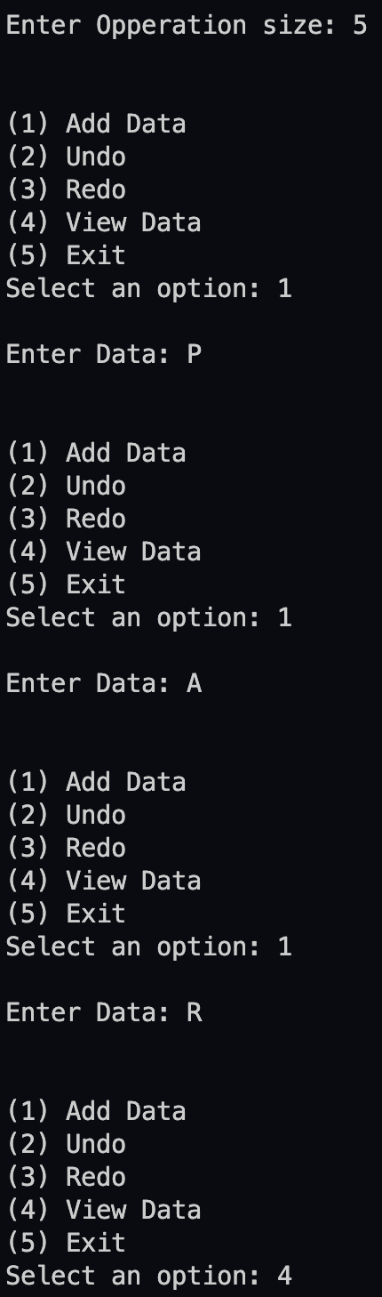

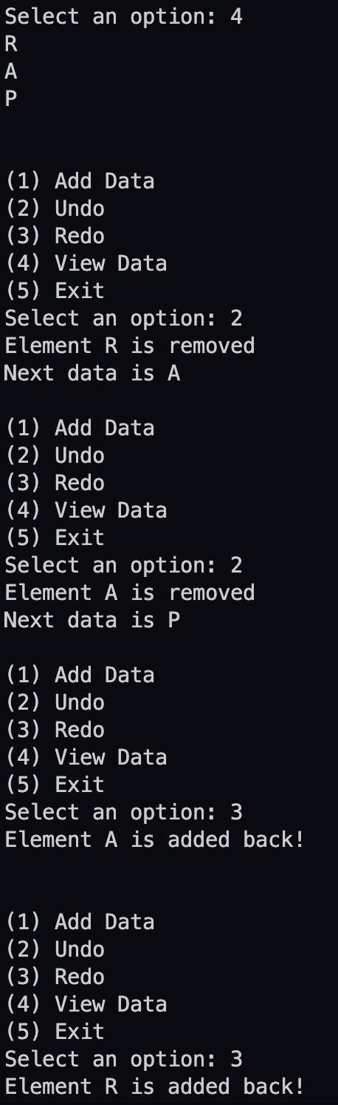

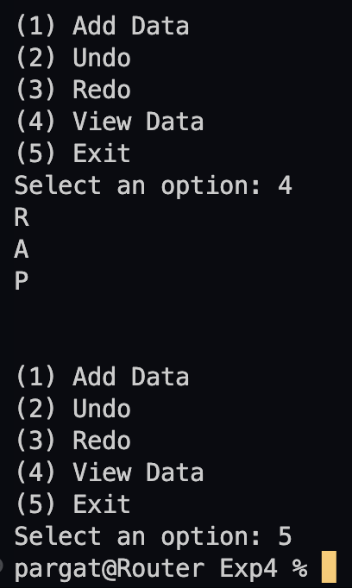

Conclusion:
Successfully implemented Undo-Redo operation implementation using static stack.

