Batch: A1 Roll No.: 16010121045

Experiment / Assignment / Tutorial No: 2

Experiment: 2

Title: Simulation of Inventory System: Newspaper Dealer Problem

Problem Statement: The newsstand buys the papers for 33 cents and sells them for 50 cents each. Newspapers not sold at the end of the day are sold as scrap for 5 cents each. Newspapers can be purchased in the bundles of 10. There are 3 types of news days: good, fair, poor with probabilities 0.35, 0.45 and 0.20 respectively. The distribution of newspaper demand is given. The problem is to estimate by simulation the optimal number of newspapers the newsstand should buy.

Expected Outcome of Experiment:

Index | Outcome
CO1 | Understand the concepts of discrete event simulation and its importance in business, science, engineering, industry and other services.

Books/ Journals/ Websites referred:
1. Jerry Banks, John Carson, Barry Nelson, and David M. Nicol, “Discrete Event System Simulation”; Fifth Edition, Prentice-Hall.
2. Averill M Law, “System Modeling & Analysis”; 4th Edition TMH.
3. Banks C M, Sokolowski J A, “Principles of Modeling and Simulation”, Wiley

Pre Lab/ Prior Concepts:
Theory:

Objective of Simulation:
The objective is to simulate the problem. The problem is to estimate the optimal number of newspapers should be kept at newsstand.
Consider Newspapers Demand per day and distribution for type of news day as follows:

Distribution of Daily Demand

Demand | Good | Fair | Poor
40 | 0.03 | 0.1 | 0.44
50 | 0.05 | 0.18 | 0.22
60 | 0.15 | 0.40 | 0.16
70 | 0.20 | 0.20 | 0.12
80 | 0.35 | 0.08 | 0.06
90 | 0.15 | 0.04 | 0.0
100 | 0.07 | 0.0 | 0.0

Newsday | Probability
Good | 0.35
Fair | 0.45
Poor | 0.20

Conceptual Model:
1. Characteristics:

- Daily purchase : 70
- Purchase in bundles of 10
- End of day , remaining newspapers are sold as scrap
- Demand: Random.
- Type of news day: Random
- Shortage: Occurs when stock falls to zero.
- The profit calculation formula:

Profit = revenue from sales – cost of news papers – lost profit from excess demand + salvage of sale of scrap papers

2. Random numbers used
- Demand
- Type of newsday

Result:

Performance measures: Performance of the system is measured in form of the average

Inventory Size | Total Profit | Lost Sales
40 | 105.4 | 134.3
50 | 159.3 | 73.1
60 | 229.8 | 52.7
70 | 184.1 | 15.3
80 | 204.3 | 1.7
90 | 101.8 | 0
100 | 52.3 | 3.4
Average | 148.1428571 | 40.07142857

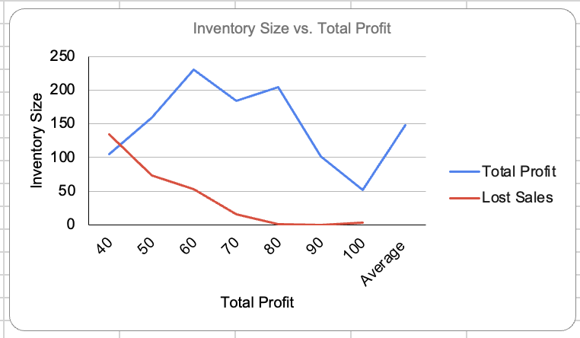

i) Average Profit = $148.14
ii) Average lost sales = $40.07

Conclusion:
Hence, successfully simulated the Newspaper problem.

Post Lab Questions:

Analyze the effect of change in probability of news days to 0.25, 0.5 and 0.25 for good, fair and poor types, respectively..

Newsday | Probability | Cum Probablity | Cum Probablity | Newsday
Good | 0.25 | 0.25 | 0 | Good
Fair | 0.5 | 0.75 | 0.25 | Fair
Poor | 0.25 | 1 | 0.75 | Poor

Distribution of Daily Demand |  |  |  | Good |  | Fair |  | Poor
Demand | Good | Fair | Poor | Cum Prob | Demand | Cum Prob | Demand | Cum Prob | Demand
40 | 0.03 | 0.1 | 0.44 | 0 | 40 | 0 | 40 | 0 | 40
50 | 0.05 | 0.18 | 0.22 | 0.03 | 50 | 0.1 | 50 | 0.44 | 50
60 | 0.15 | 0.4 | 0.16 | 0.08 | 60 | 0.28 | 60 | 0.66 | 60
70 | 0.2 | 0.2 | 0.12 | 0.23 | 70 | 0.68 | 70 | 0.82 | 70
80 | 0.35 | 0.08 | 0.06 | 0.43 | 80 | 0.88 | 80 | 0.94 | 80
90 | 0.15 | 0.04 | 0 | 0.78 | 90 | 0.96 | 90 | 1 | 90
100 | 0.07 | 0 | 0 | 0.93 | 100 | 1 | 100 | 1 | 100

Total Profit Changed from $233.7 to $208.4 for the same inventory size i.e 70.

