Batch: A2 Roll No.: 16010121045
Experiment / assignment / tutorial No.
Grade: AA / AB / BB / BC / CC / CD /DD

Signature of the Staff In-charge with date

TITLE: Regular expression in Python

AIM: Program to demonstrate use of regular expressions in pattern matching.
______________________________________________________________________
Expected OUTCOME of Experiment: Use of basic data structure in Python.
_____________________________________________________________________
Resource Needed: Python IDE
_____________________________________________________________________
Theory:
A RegEx, or Regular Expression, is a sequence of characters that forms a search pattern.
RegEx can be used to check if a string contains the specified search pattern.

RegEx Module
Python has a built-in package called re, which can be used to work with Regular Expressions. Import the re module: import re

RegEx in Python
When you have imported the re module, you can start using regular expressions:

Example
Search the string to see if it starts with "The" and ends with "Spain":
import re
txt = "The rain in Spain"
x = re.search("^The.*Spain$", txt)

RegEx Functions
The re module offers a set of functions that allows us to search a string for a match:
Function | Description
findall | Returns a list containing all matches
search | Returns a Match object if there is a match anywhere in the string
split | Returns a list where the string has been split at each match
sub | Replaces one or many matches with a string

Metacharacters
Metacharacters are characters with a special meaning:
Character | Description | Example
[] | A set of characters | "[a-m]"
\ | Signals a special sequence (can also be used to escape special characters) | "\d"
. | Any character (except newline character) | "he..o"
^ | Starts with | "^hello"
$ | Ends with | "world$"
* | Zero or more occurrences | "aix*"
+ | One or more occurrences | "aix+"
{} | Exactly the specified number of occurrences | "al{2}"
| | Either or | "falls|stays"
() | Capture and group

Special Sequences
A special sequence is a \ followed by one of the characters in the list below, and has a special meaning:
Character | Description | Example
\A | Returns a match if the specified characters are at the beginning of the string | "\AThe"
\b | Returns a match where the specified characters are at the beginning or at the end of a word  (the "r" in the beginning is making sure that the string is being treated as a "raw string") | r"\bain"  r"ain\b"
\B | Returns a match where the specified characters are present, but NOT at the beginning (or at the end) of a word  (the "r" in the beginning is making sure that the string is being treated as a "raw string") | r"\Bain"  r"ain\B"
\d | Returns a match where the string contains digits (numbers from 0-9) | "\d"
\D | Returns a match where the string DOES NOT contain digits | "\D"
\s | Returns a match where the string contains a white space character | "\s"
\S | Returns a match where the string DOES NOT contain a white space character | "\S"
\w | Returns a match where the string contains any word characters (characters from a to Z, digits from 0-9, and the underscore _ character) | "\w"
\W | Returns a match where the string DOES NOT contain any word characters | "\W"
\Z | Returns a match if the specified characters are at the end of the string | "Spain\Z"

Sets
A set is a set of characters inside a pair of square brackets [] with a special meaning:
Set | Description
[arn] | Returns a match where one of the specified characters (a, r, or n) are present
[a-n] | Returns a match for any lower case character, alphabetically between a and n
[^arn] | Returns a match for any character EXCEPT a, r, and n
[0123] | Returns a match where any of the specified digits (0, 1, 2, or 3) are present
[0-9] | Returns a match for any digit between 0 and 9
[0-5][0-9] | Returns a match for any two-digit numbers from 00 and 59
[a-zA-Z] | Returns a match for any character alphabetically between a and z, lower case OR upper case
[+] | In sets, +, *, ., |, (), $,{} has no special meaning, so [+] means: return a match for any + character in the string

Problem Definition:
1. For given program find output
Sr. No. | Program | Output
1 | import re  txt = "The rain in Spain"  x = re.findall("ai", txt)  print(x) | [‘ai’, ‘ai’]
2 | import re  txt = "The rain in Spain"  x = re.findall("Portugal", txt)  print(x) | []
3 | import re  txt = "The rain in Spain"  x = re.search("\s", txt)  print("The first white-space character is located in position:", x.start()) | The first white-space character is located in position: 3
4 | import re  txt = "The rain in Spain"  x = re.search("Portugal", txt)  print(x) | None
5 | import re  txt = "The rain in Spain"  x = re.split("\s", txt)  print(x) | [‘The’,  ‘rain’, ‘in’,  ‘Spain’]
6 | import re  txt = "The rain in Spain"  x = re.split("\s", txt, 1)  print(x) | [‘The’, ‘rain  in Spain’]
7 | import re  txt = "The rain in Spain"  x = re.sub("\s", "9", txt)  print(x) | The9rain9in  9Spain
8 | import re  txt = "The rain in Spain"  x = re.sub("\s", "9", txt, 2)  print(x) | The9rain9in  Spain
9 | import re  txt = "The rain in Spain"  x = re.search("ai", txt)  print(x) #this will print an object | <re.Match object; span=(5, 7), match='ai'>
10 | import re  txt = "The rain in Spain"  x = re.search(r"\bS\w+", txt)  print(x.span()) | (12, 17)

2. WAP to verify whether his credit card numbers are valid or not. A valid credit card
from ABC Bank has the following characteristics:
- It must start with a 4,5 or 6 .
- It must contain exactly 16 digits.
- It must only consist of digits (0-9).
- It may have digits in groups of 4, separated by one hyphen ‘-’

3. From given string extract phone numbers only and save it into list.
Txt = “Dave Martin
615-555-7164
173 Main St., Springfield RI 55924
davemartin@bogusemail.com

Charles Harris
800-555-5669
969 High St., Atlantis VA 34075
charlesharris@bogusemail.com

Eric Williams
560-555-5153
806 1st St., Faketown AK 86847
laurawilliams@bogusemail.com

Corey Jefferson
900-555-9340
826 Elm St., Epicburg NE 10671
coreyjefferson@bogusemail.com”

Books/ Journals/ Websites referred:
- Reema Thareja, Python Programming: Using Problem Solving Approach, Oxford University Press, First Edition 2017, India
- Sheetal Taneja and Naveen Kumar, Python Programming: A modular Approach, Pearson India, Second Edition 2018,India

Implementation details:

2.

import re
str=input("Enter Credit Card numbers to check: ")
# checking the pattern using regex
print("Pattern Matched") if re.search(r"^[456]\d\d\d-\d\d\d\d-\d\d\d\d-\d\d\d\d$",str) else print("Not Matched")

3.

import re
str='''Dave Martin
615-555-7164
173 Main St., Springfield RI 55924
davemartin@bogusemail.com

Charles Harris
800-555-5669
969 High St., Atlantis VA 34075
charlesharris@bogusemail.com

Eric Williams
560-555-5153
806 1st St., Faketown AK 86847
laurawilliams@bogusemail.com

Corey Jefferson
900-555-9340
826 Elm St., Epicburg NE 10671
coreyjefferson@bogusemail.com'''
str1=str.splitlines()
# Spliting the multiline string at new lines
for i in str1:
if(re.search(r"^\d\d\d-\d\d\d-\d\d\d\d$",i)):
print(i)
# Checking for pattern and printing if found

Output(s):

2.

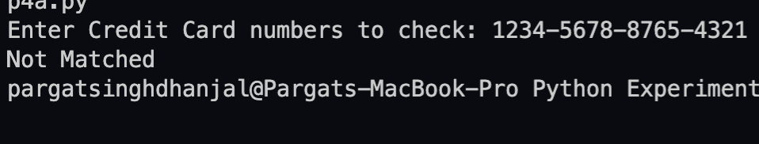

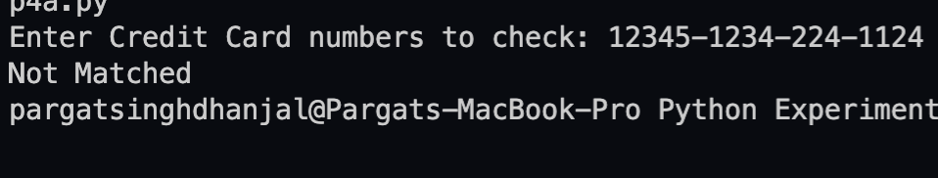

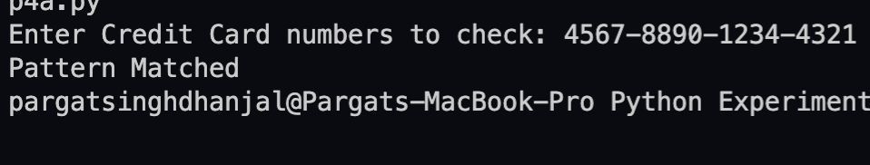

3.

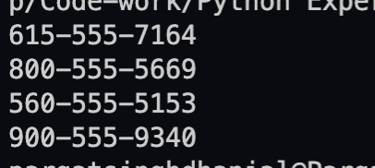

Conclusion:

The experiment taught us the concept of RegEx module in Python, which is immensely
helpful while working with text files to find matches or certain occurrences of data, which will help us to analyse data properly. It also helped us understand the logic development and RegEx sequence implementation skills.

Post Lab Descriptive Questions
What is difference in match and search function? Explain with suitable example.

re.match() : This function will search the regular expression pattern and return the first matched occurrence. The function only checks for match at the beginning of the string. So, if a match is found in the first line, it returns the match object or else it return a null object.

Eg:
import re
str1="Hello my name is Pargat"
ans=str(re.match('Pargat', str1))
if(ans=='None'):
print("No Match")
else:
print("Matched!")

Output
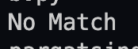

Here the output says “No Match” even though “Pargat” is present in the test string because the re.match() function only checks at the start of the string and not the entire string.

re.search() : This function will search the regular expression pattern and return the first occurrence. Unlike re.match(), it will check all lines of test string. The re.search() function returns a match object when the pattern is found and “null” if the pattern is not found.

Eg:
import re
str1="Hello my name is Pargat"
ans=str(re.search('Pargat', str1))
if(ans=='None'):
print("No Match")
else:
print("Matched!")
Output:
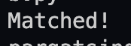

Here the output says “Matched!” because the re.search() function checks the entire string for the word and not only the beginning hence the output.

Date: _____________ Signature of faculty in-charge

