Course Name: | Elements of Electrical and Electronics Engineering | Semester: | I/II
Date of Performance: | 4/1/2022 | Batch No: | A2
Faculty Name: | Maruti Zalte | Roll No: | 16010121045
Faculty Sign & Date: |  | Grade/Marks: | / 25

Experiment No: 9

Title: Measurement of Power using Two Wattmeter Method

Aim and Objective of the Experiment:
- To measure the power of three phase power using Two Wattmeter Method

COs to be achieved:
CO1: Analyze resistive networks excited by DC sources using various network theorems.

Circuit Diagram/ Block Diagram:
Circuit Diagram
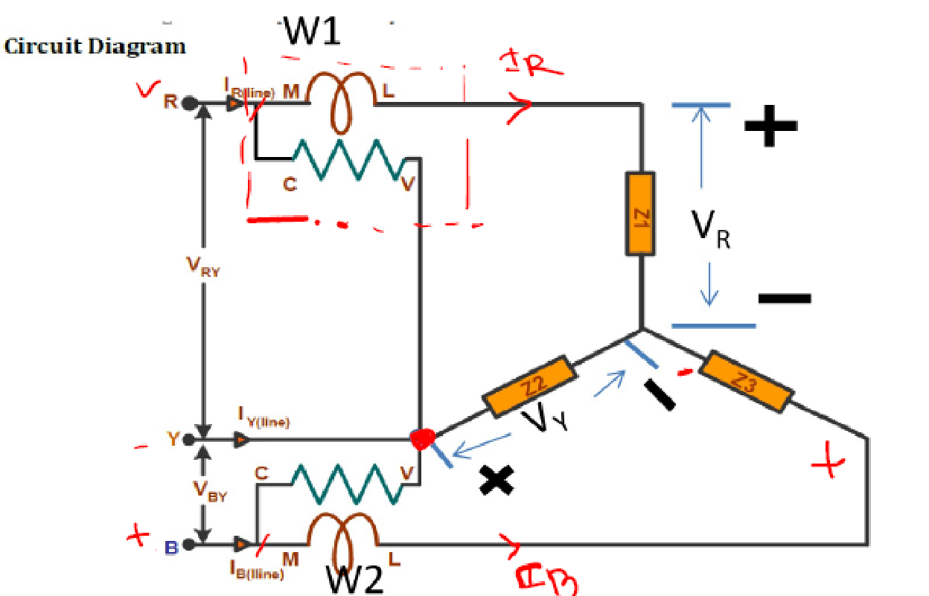

Stepwise-Procedure:
- Connect the circuit as shown in circuit diagram
- Increase the load and note down the reading VL,IL,W1 and W2
- Practically you will obtain total power W=W1+W2
- Theoretically power is measured by using formula P=√3V_{L}I_{L}cosϕ,
using cosϕ=1(unity) for resistive load.

Observation Table:
Sr.no | V_{L} | I_{L} | W₁ | W₂ | W=W₁+W₂ | P=√3V_{L}I_{L}COSϕ | Load
1 | 266 | 1.53 | 352 | 354 | 706 | 702.93 | Resistive
2 | 379 | 0.66 | -53.3 | 184 | 130.7 | 134.31 | Inductive(cos ϕ=0.31)
3 | 328 | 1.73 | -120 | 414 | 294 | 304.67 | Inductive(cos ϕ=0.31)
4 | 160 | 2.77 | 389 | 373 | 763 | 759.97 | Reactance(cos ϕ=0.99)

Screenshot of Output:
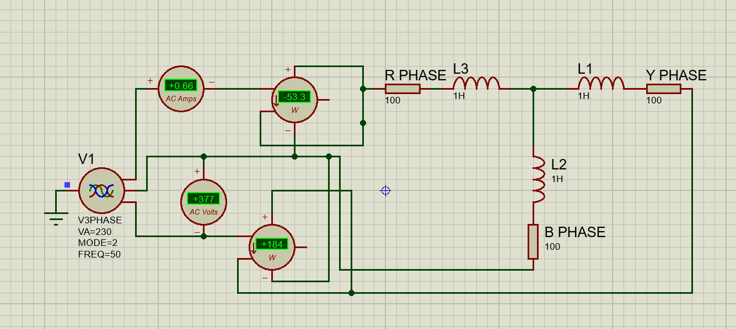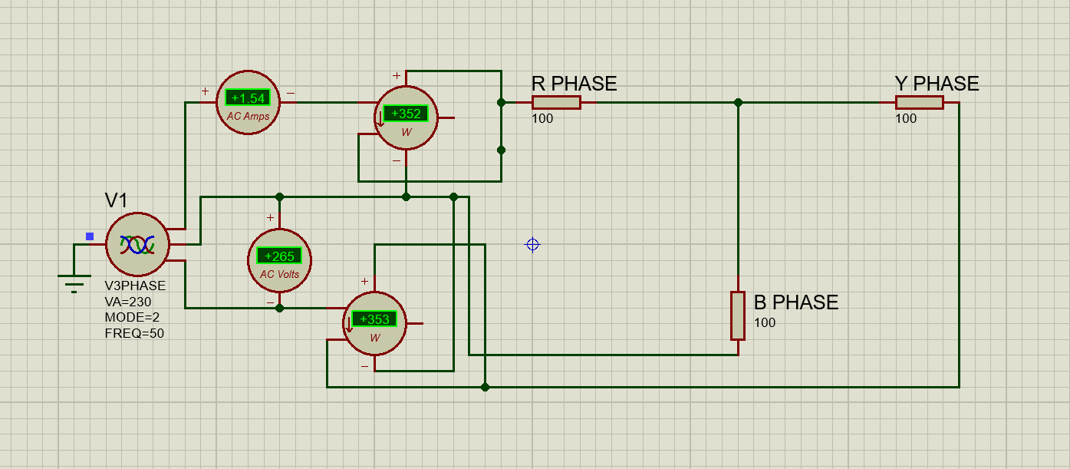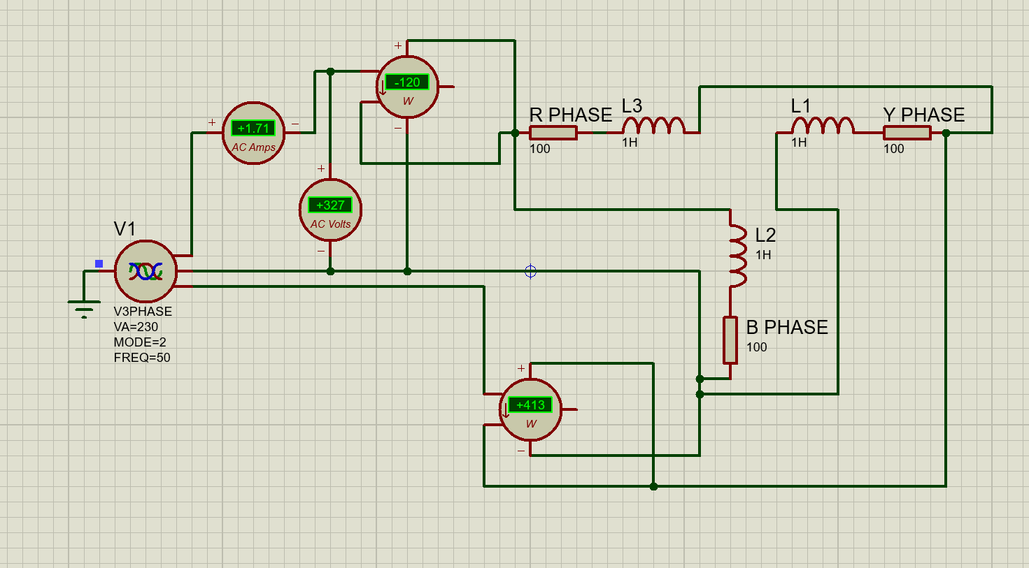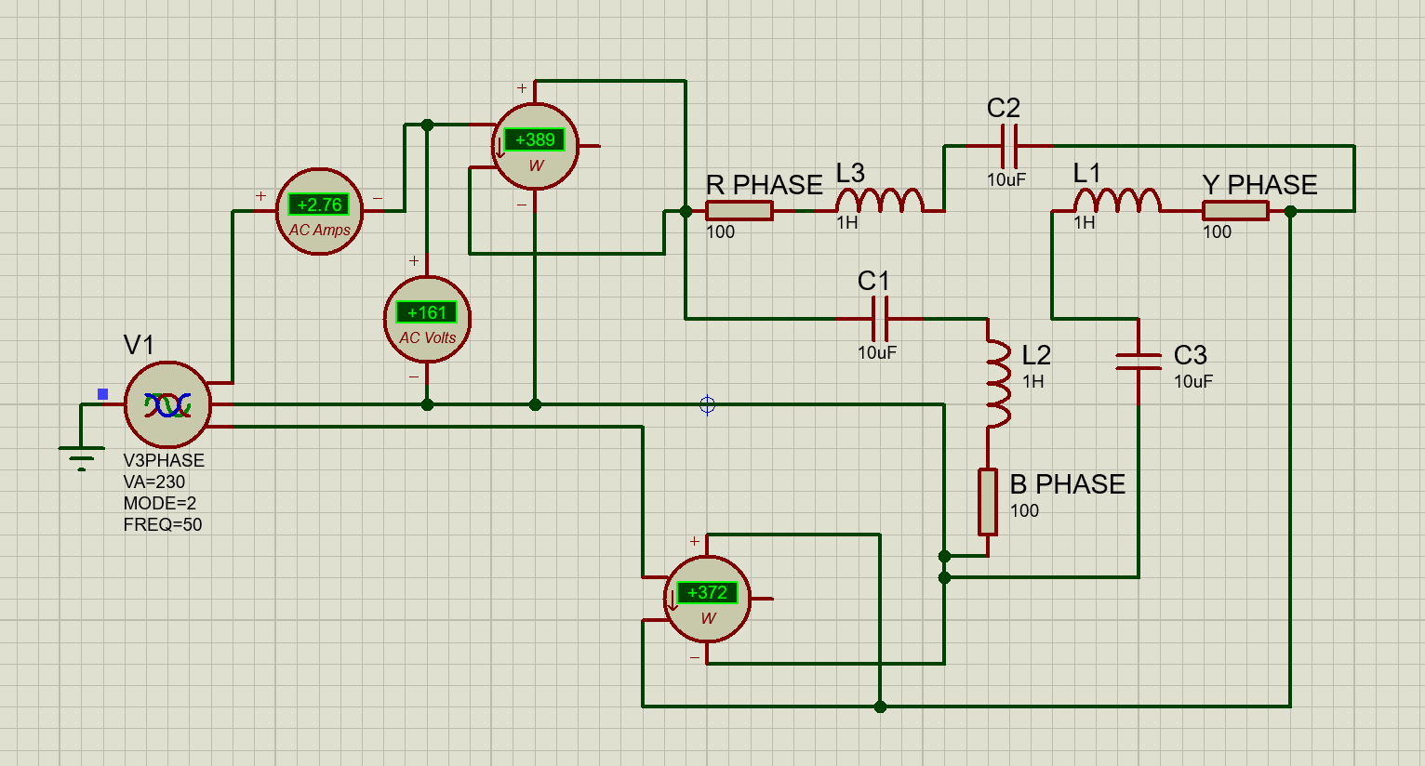
Pargat Singh
Pargat Singh
Pargat Singh
Pargat Singh

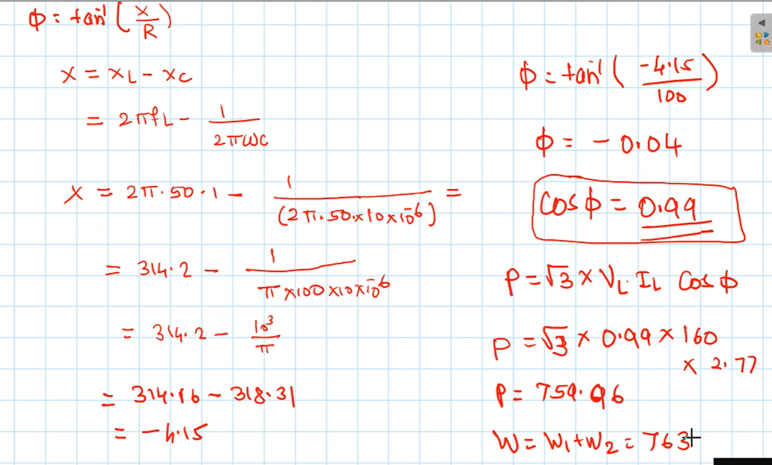
Calculations

Conclusion:
The measurement of three phase power for both, star and delta connection was successfully measured
using two watt meters.

Signature of faculty in-charge with Date:

